**Yum package management**

**What is YUM?**

YUM (Yellowdog Updater Modified) is an open-source command-line as well as graphical-based package management tool for RPM (RedHat Package Manager) based Linux systems.

It allows users and system administrators to easily install, update, remove or search software packages on a system.

1. ***Install a Package with YUM***

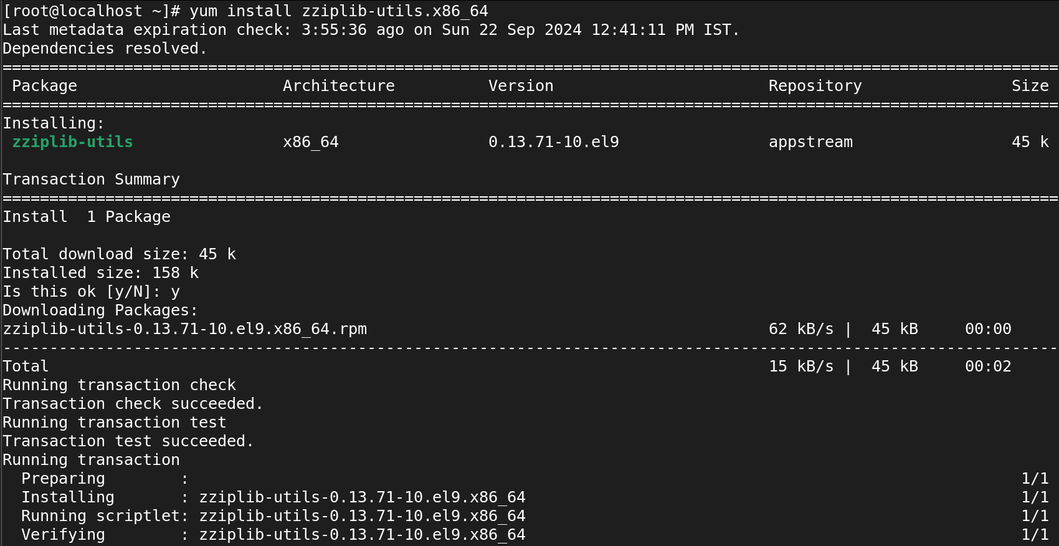

1. ***Removing a Package with YUM***

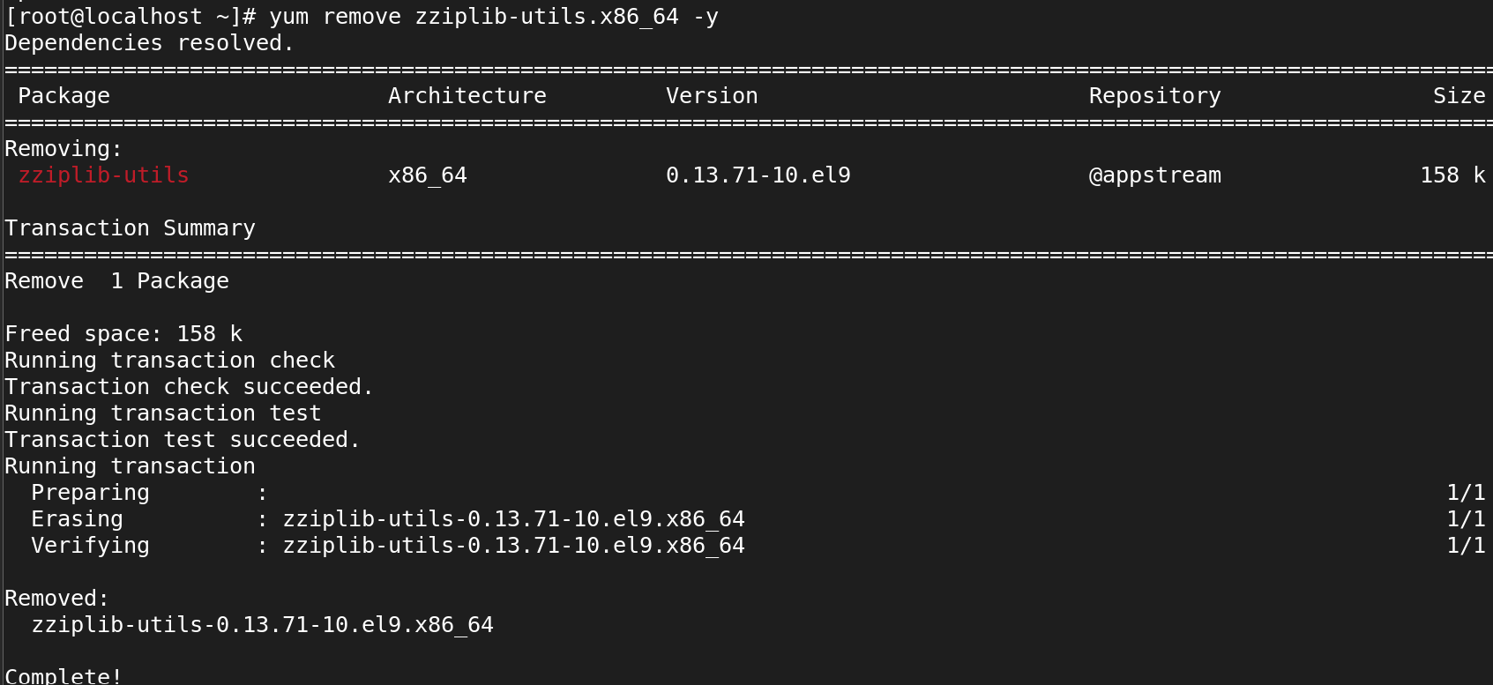

1. ***Check for Available Updates using Yum***

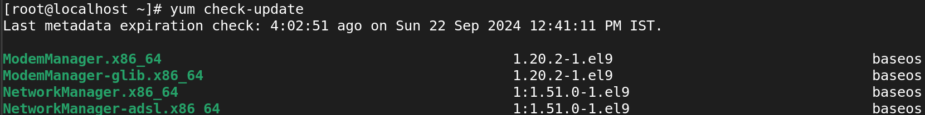

1. ***Get Information about a Package using YUM***

***Using the yum info we can able to see all information of packages and updates***

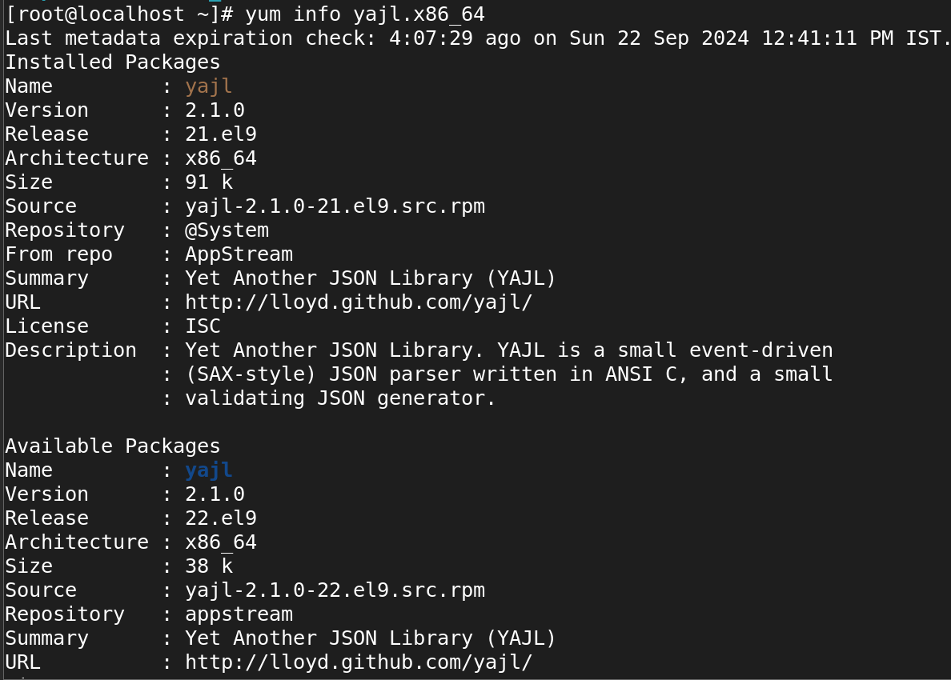

1. ***Updating a Package using YUM***

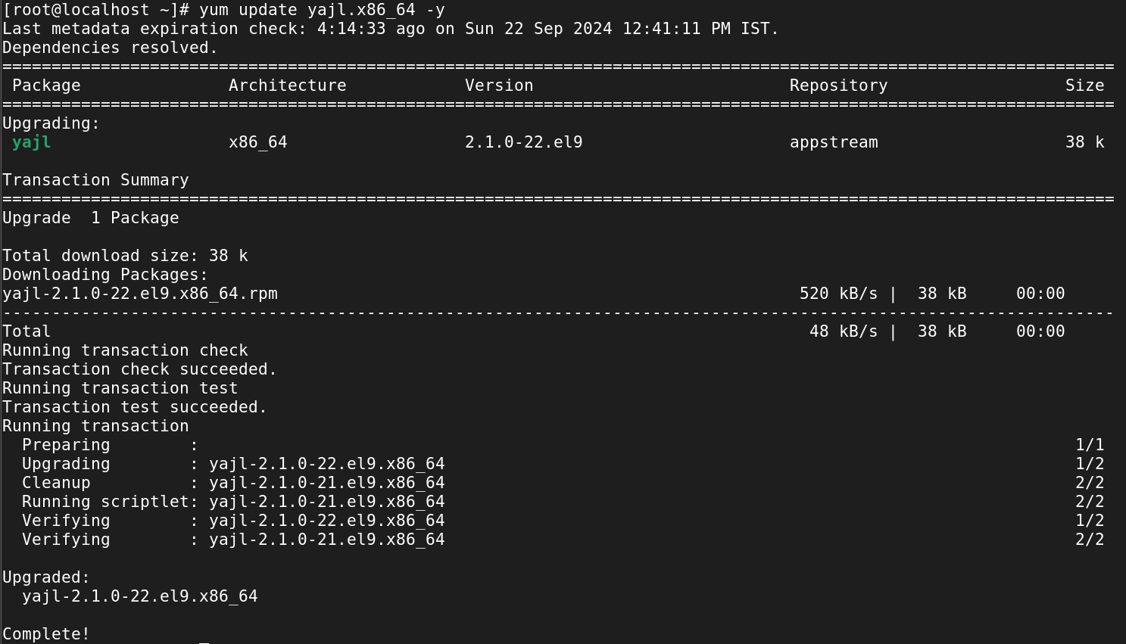

1. ***List a Package using YUM***

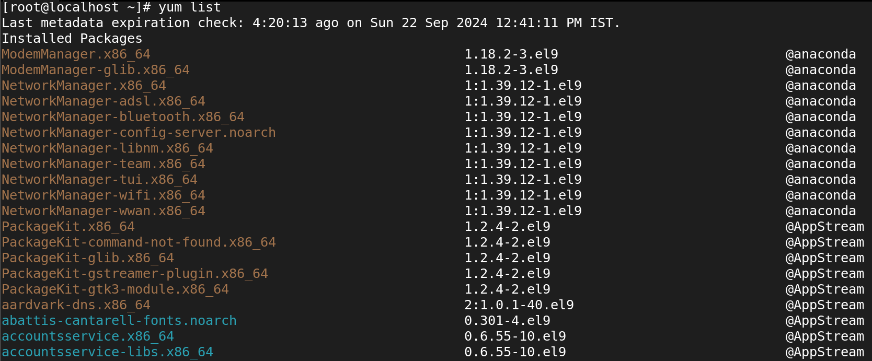

1. ***How to count a listed package using yum***

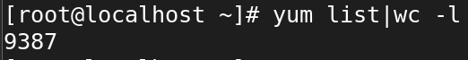

1. ***List all Installed Packages using YUM***

***The installed packages show the red colour.***

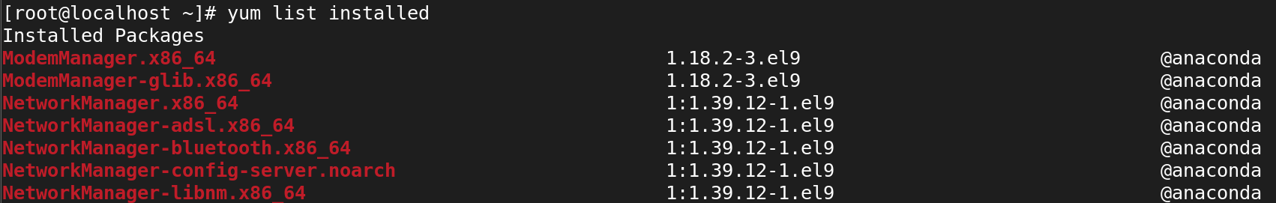

1. ***List Enabled Yum Repositories***

***It show only enabeled repo***

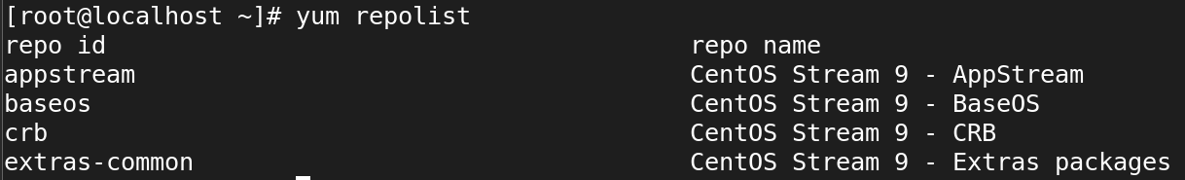

1. ***To List all repo using Yum Repositories***

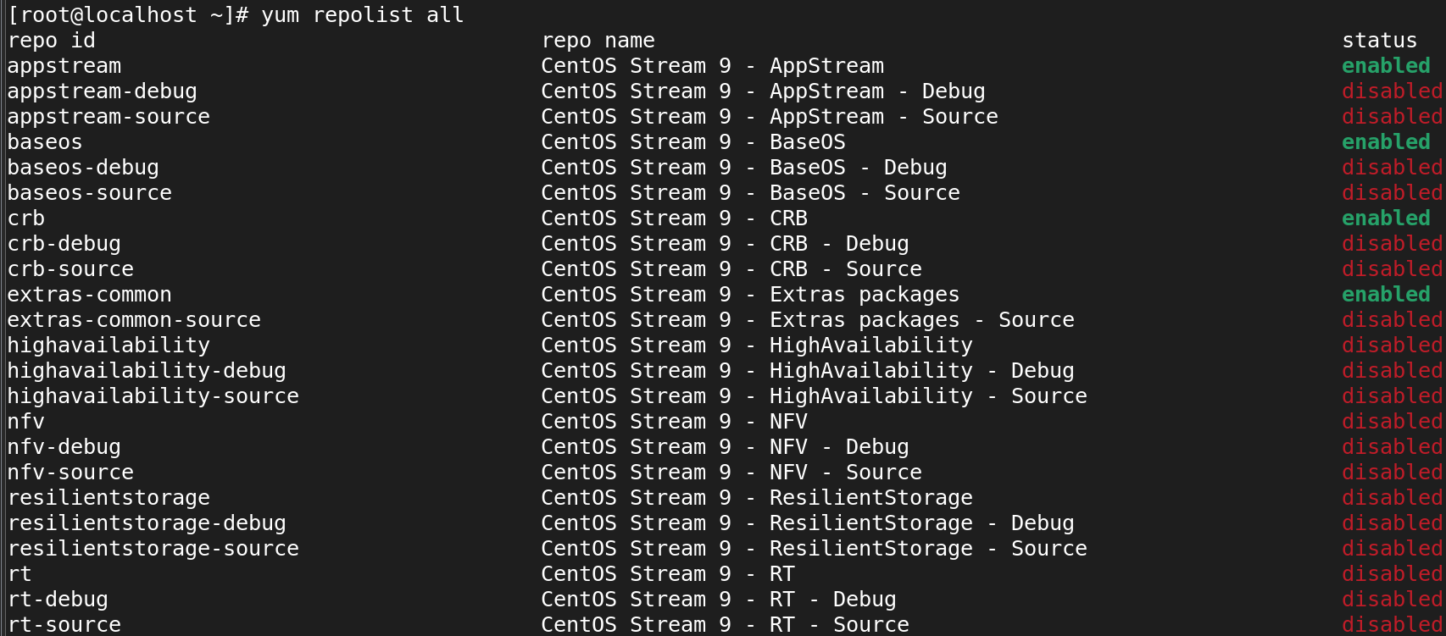

1. ***Clean Yum Cache***



1. ***View History of Yum***

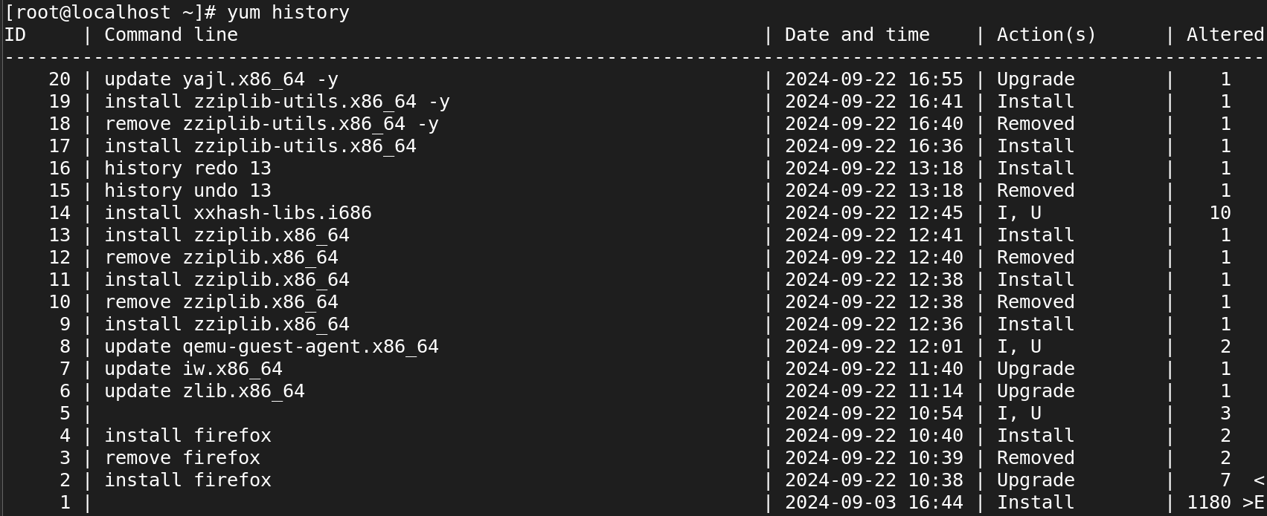

**# yum history**

**#yum history undo 21**

**#yum history redo 30**

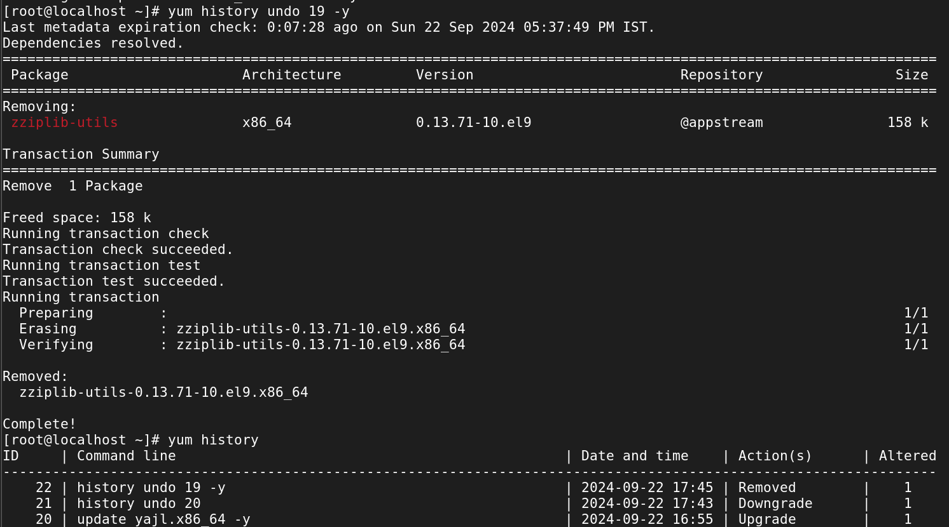

1. ***The command use to enable and disable the repository***

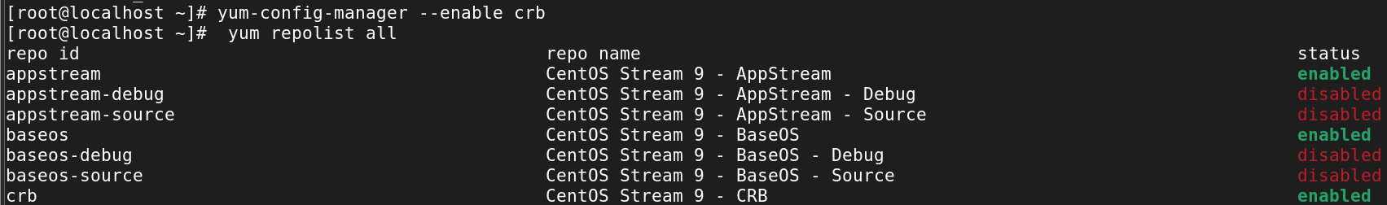

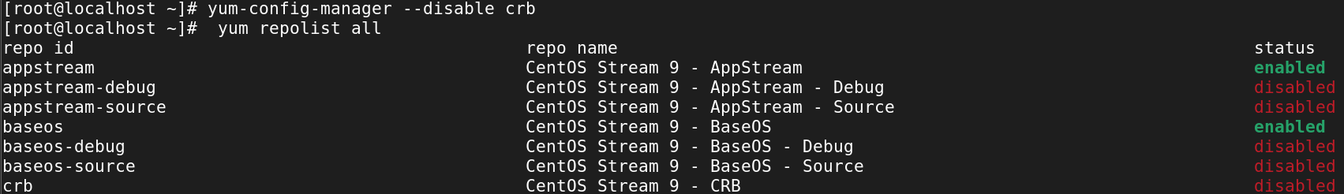

1. ***Search for a Package***

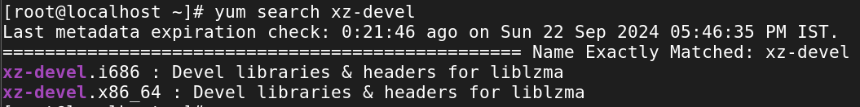

Yum list (package name)

It will show the installed OR available in the packages

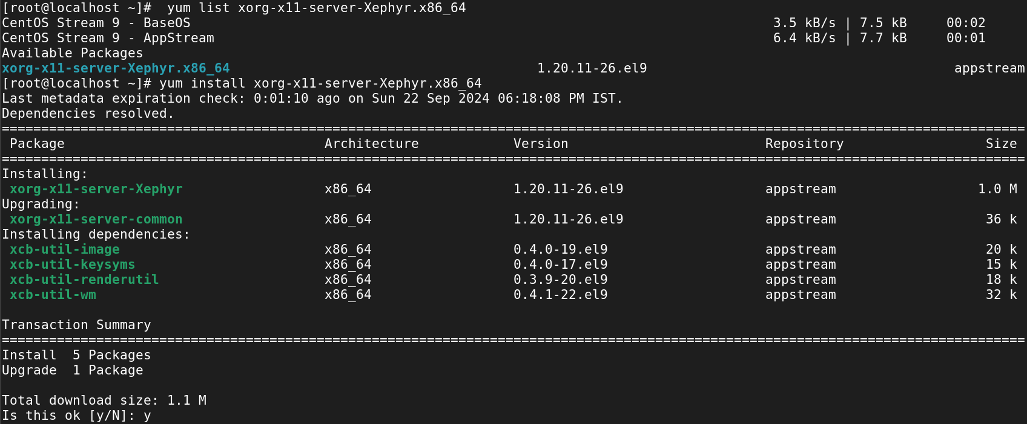

1. ***Install a Package from a Specific Repository***

Eventhough crb is disable by using this command we can install packages.

**# yum --enablerepo=crb install xdp-tools.x86_64**



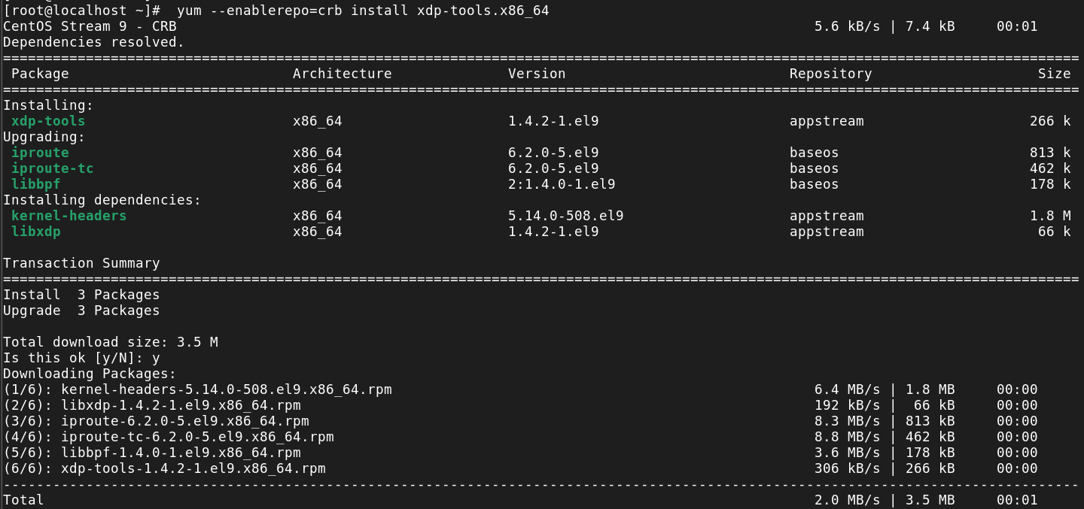

1. ***Yum Provides Function***

**# yum provides /etc/httpd/conf/httpd.conf**

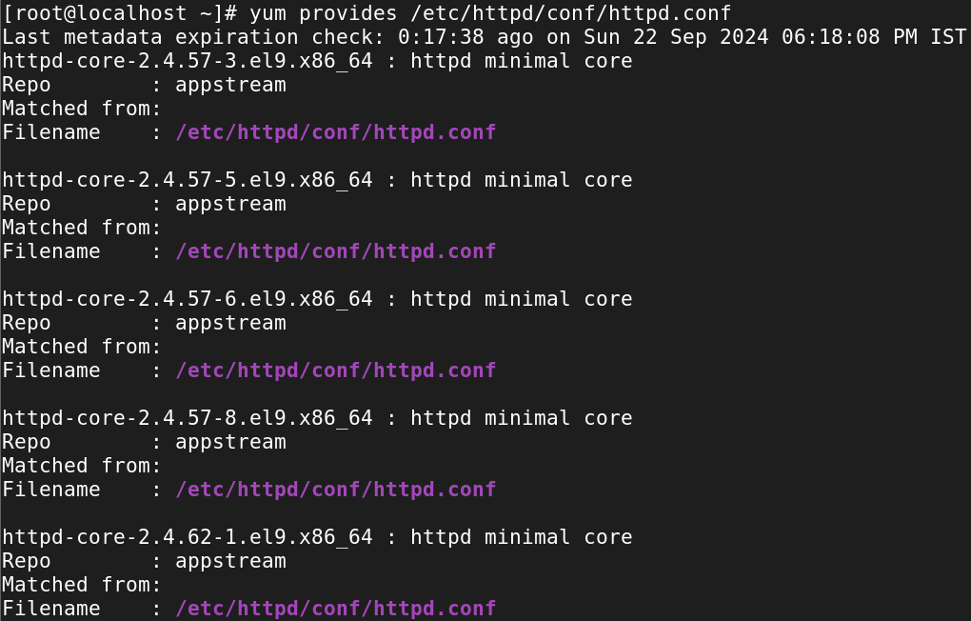

***#yum --disablerepo=* --enablerepo=appstream repolist***